Lab 2: Creating and validating ABAC policies with Starburst Galaxy
Estimated completion time
- 30 minutes

Learning objectives
- In this lab, you will apply existing tags, and their associated attribute-based access controls, to particular columns and then verify the these policies deny access to the specific columns.

Activities
- Prepare for the exercise
- Create Sales schema
- Explore existing tags
- Assign tags to customer table
- Assign tag to orders table
- Grant privileges to mktg role
- Grant privileges to sales role
- Understand existing policies on pii and sales tags
- Verify sales role’s privileges
- Verify mktg role’s privileges

Step 1 - Prepare for the exercise
- Sign in and verify the students role is selected in the upper-right corner.
- Ensure the aws-us-east-1-free Cluster is reporting a Status of Running.
- In the Query editor, select aws-us-east-1-free in the cluster pulldown.

Note: If you did not previously create a schema, execute the following SQL statement. Make sure that you replace yourname with your actual name, or another identifier that you prefer. Only use lowercase characters and numbers; no special characters or spaces.

CREATE SCHEMA students.yourname;

Step 2 - Create Sales schema
Create a schema and associated tables for the Sales department and load them with test data.

CREATE SCHEMA students.yourname_sales;
USE students.yourname_sales;

CREATE TABLE orders AS
SELECT * FROM tpch.tiny.orders;

CREATE TABLE customer AS
SELECT * FROM tpch.tiny.customer;

Query both tables to verify they contain test data.

Step 3 - Explore existing tags
Select Access control and then Tags in the left navigation. The All tags page will render.

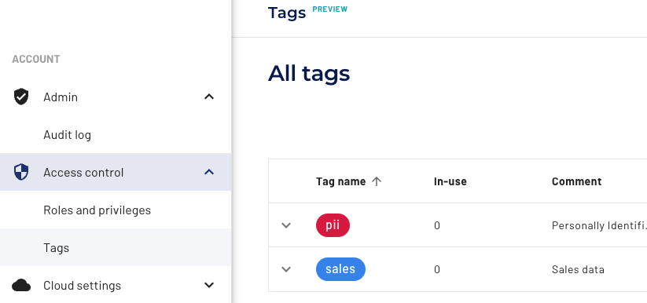

Click on the down arrow to the left of the Tag name items in the list to expand to see additional tabs that are nested.

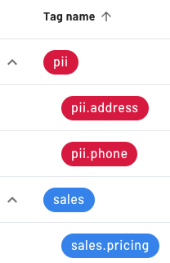

The top-level tags of pii and sales, and their associated nested tags, will be used in this exercise. To see the full comment for each, scroll the table contents to the right and click on the vertical ellipses and then select Edit tag settings.

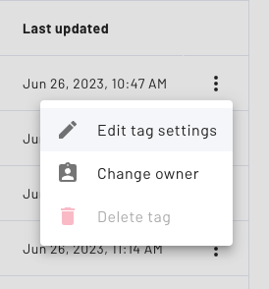

You can now see the full Description of the tag.

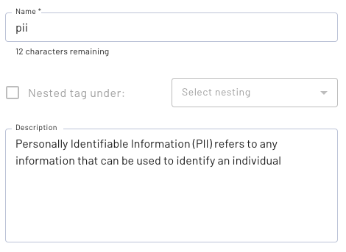

Step 4 - Assign tags to customer table
Select Catalogs in the left navigation. Under Catalogs, in the middle pane, expand students and then yourname_sales. Click on the customer table.

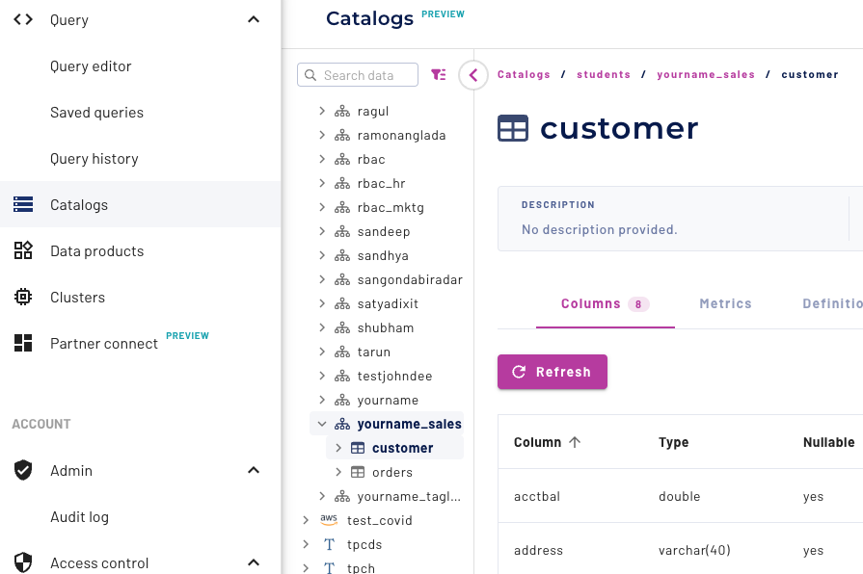

The Columns tab should be selected. Scroll down until you see the address column name and then look to the right to find the UI column titled Tags. Click the + next to No tags assigned as show in the far right in the following screenshot.

Expand the Add tags drop-down, and check the box in front of pii.address.
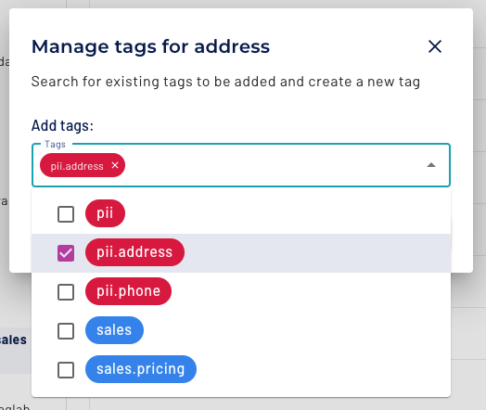

Click once outside the drop-down to close it. Press the Save changes button.

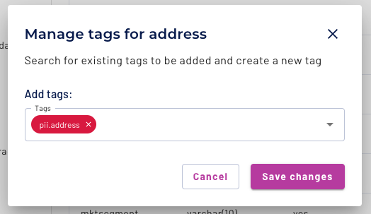

Notice that the tag is now assigned.

- Using the same procedure, apply the pii.phone tag to the phone column.
- Using the same procedure, apply the pii tag to the name column.
- Confirm that all 3 tags were assigned correctly.

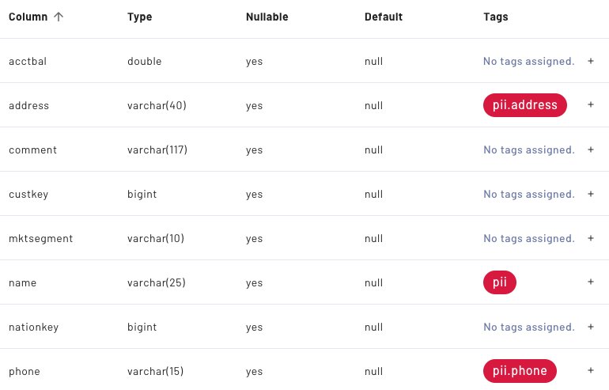

Step 5 - Assign tag to orders table
Using the process from Step 4, apply the sales.pricing tag to the totalprice column of the orders table. Confirm that the tag was assigned correctly.

Step 6 - Grant privileges to mktg role
Select Catalogs in the left navigation. Under Catalogs, in the middle pane, expand students and then yourname_sales. Click on the customer table.

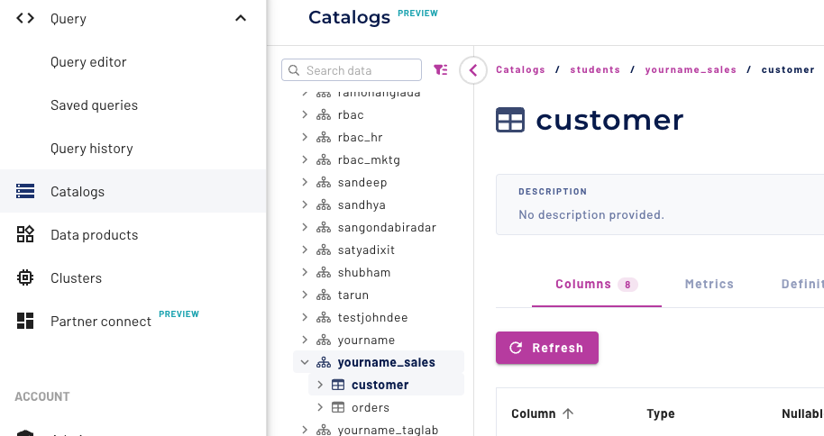

Click on the Privileges tab on the far right of the screen. Click on the Add privileges button that appears, which surfaces the Add privileges dialogue box.

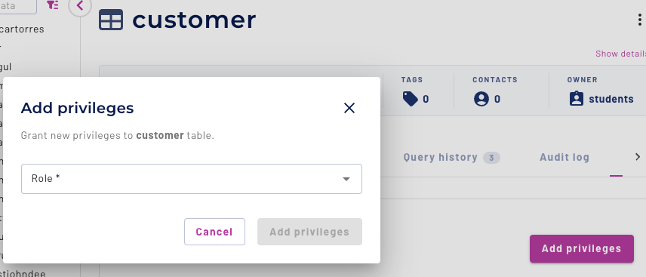

Choose the mktg role in the pulldown control. Confirm that the default Allow radio button is selected.

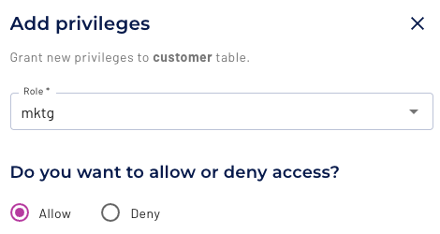

Now it’s time to select the appropriate privileges. You want to enable select rights for this table.

Check the box labeled Select from table and then click the Add privileges button.

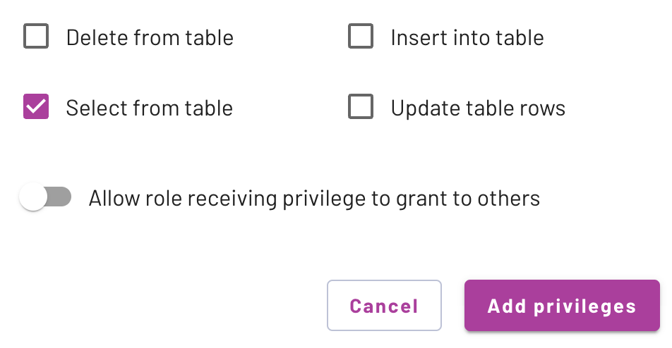

You will see a new entry in the Privileges table listing the hr role as Select from table privileges.

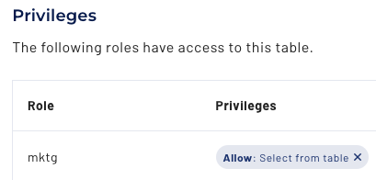

Using the same procedure, grant the same privilege to the mktg role for the orders table.

Step 7 - Grant privileges to sales role
Using the process from Step 6, grant the same privilege on the customer and orders tables to the sales role.

Step 8 - Understand existing policies on pii and sales tags
An administrator previously established some policies that help control access against the pii and sales tags you applied to your customer and orders table in Step 4 and Step 5.

Note: this step is showing you what those configurations would look like if you had permissions to edit them.

An access control policy was created and named deny_pii.

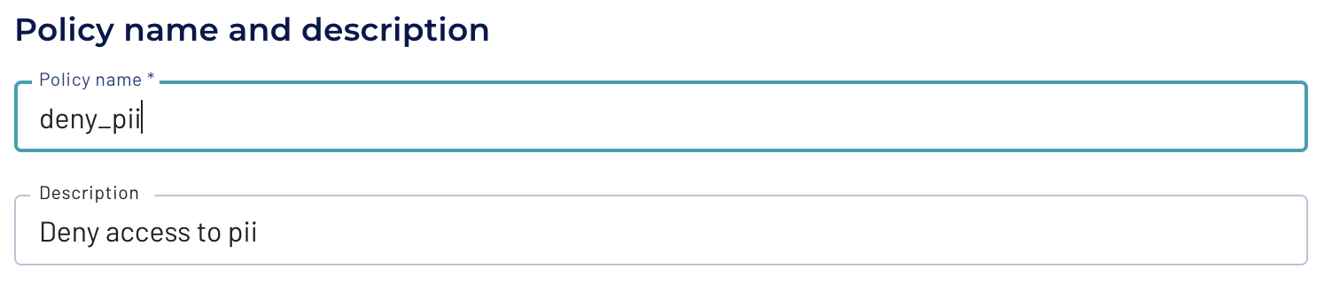

It is applicable for the entire students catalog.

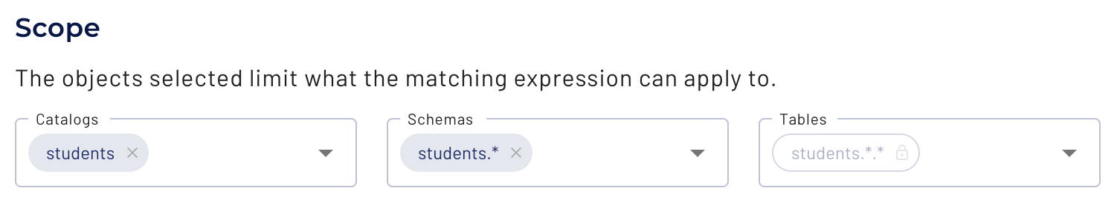

The policy is aligned to any tag that is nested under the pii tag.

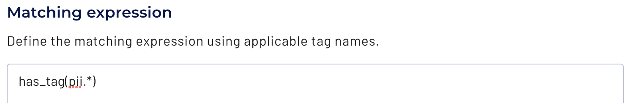

Note: has_tag(pii.*) will only match nested tags (ex: pii.phone or pii.address) and will not match the parent tag. Conversely, has_tag(pii) will only match the parent tag (ex: pii) and will not match any of the nested tags. If you wanted to match both the parent tag and the nested tags, you would use the following; has_tag(pii) OR has_tag(pii.*).

The policy prevents read access to items that have tags aligned with the Matching expression.

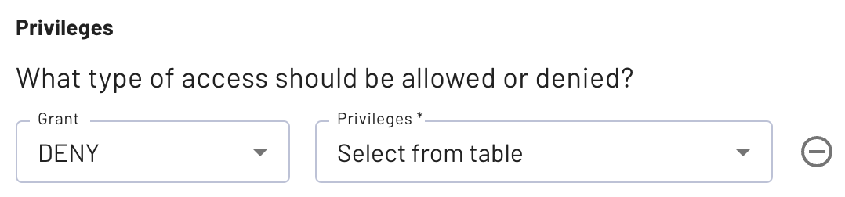

This policy is bound to a role with the same name; deny_pii. That role has been added to the sales and mktg roles in order for the tag-based policy to be complete.

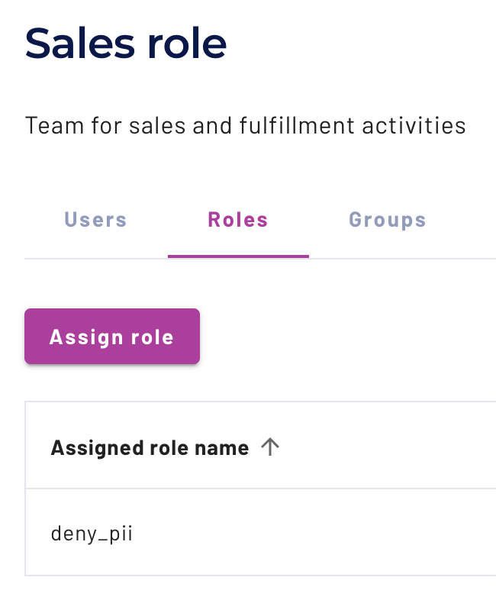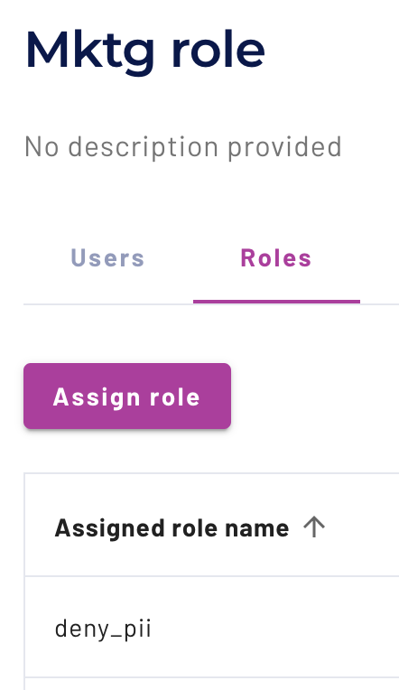

Another role with a similar policy, both named deny_pricing_data, is present that has the following Matching expression.

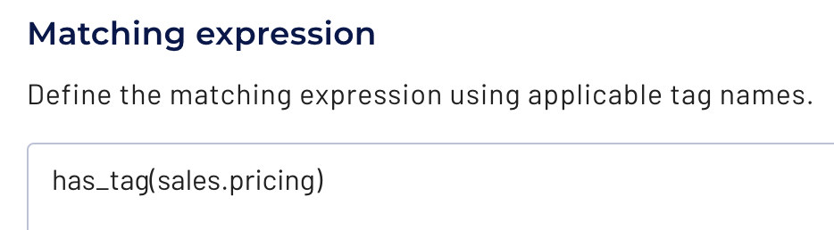

Based on the earlier explanation, this policy is configured to only consider the pricing tag that is nested under the sales tag. Neither the parent tag, or any other nested tag, matches.

This role has only been added to the mktg role in addition to the earlier role.

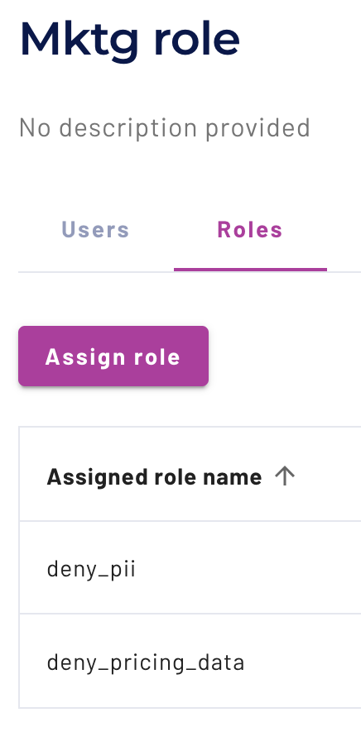

Step 9 - Verify sales role’s privileges
The prior step declares that the sales role was denied access to the address and phone columns in the customer table. No policies were established against the orders table.

Return to the Query editor and expand the aws-us-east-1-free cluster. You will see multiple catalogs listed.

In the upper right corner of the UI, click on the down arrow next to your email address, and hover over students in the pull-down menu that is exposed. A submenu will surface as shown below and click on sales.

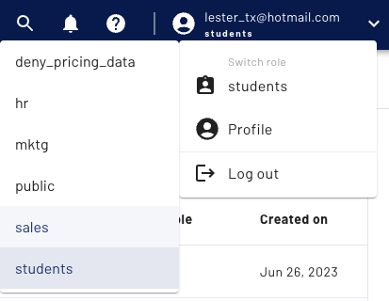

The upper right corner of the UI will now indicate your session has changed to the sales role.



The expandable cluster/catalog/schema list will now have the catalogs view collapsed. Drill back into the aws-us-east-1-free cluster and the students catalog. Expand the yourname_sales schema.

The customer and orders tables should be present. Verify that you can query both of them using the code below.

USE students.yourname_sales;

SELECT * FROM orders o JOIN customer c ON (o.custkey = c.custkey);

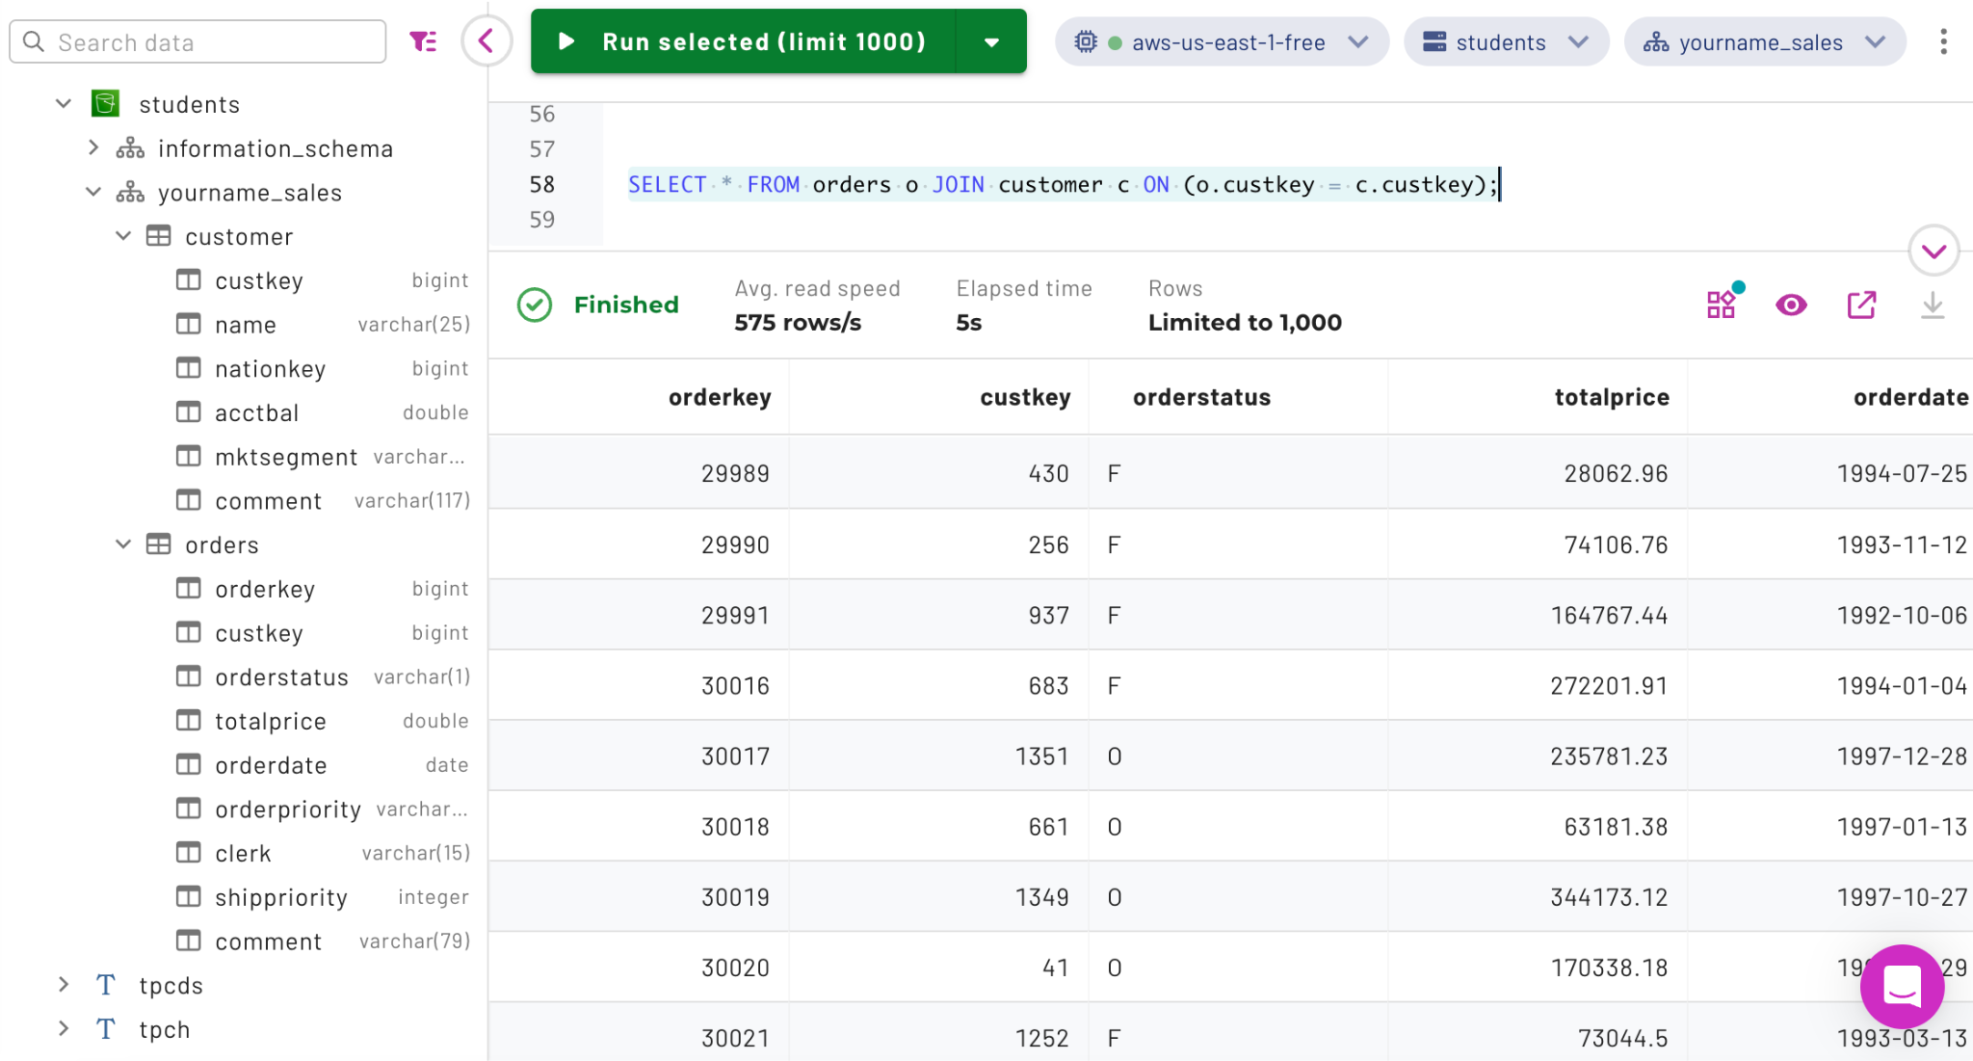

On the surface, this seems problematic since there should have been some restrictions on the customer table that prevented these results from being returned.

Run a simple SELECT * FROM orders; query to verify that it returns unimpeded.

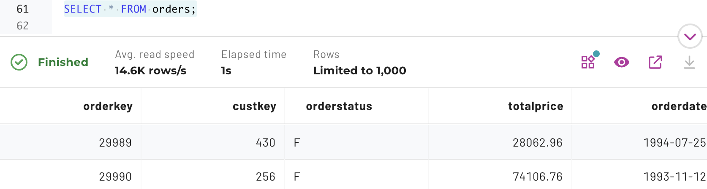

Run the same thing against the customer table.

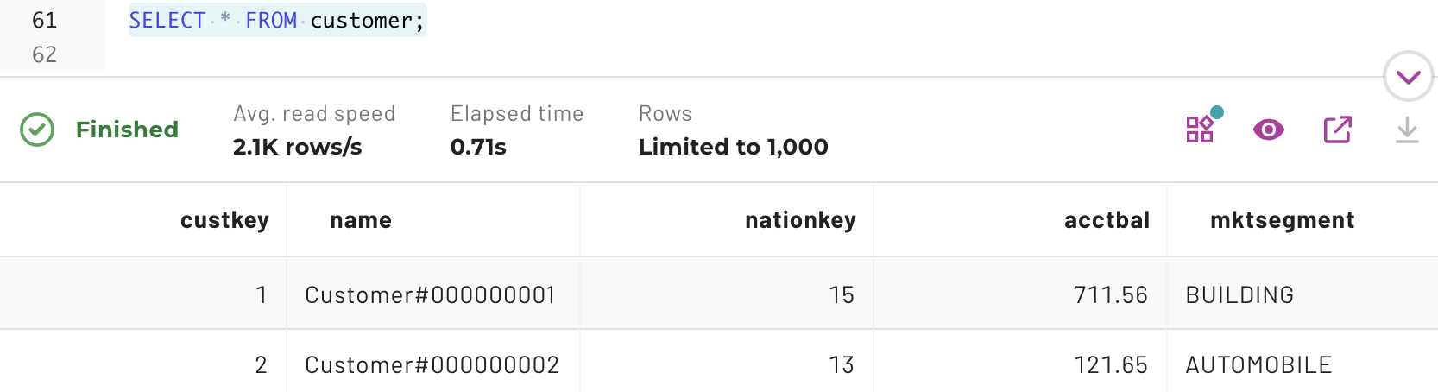

This seems wrong as some of the pii tagged columns should not be accessible. Reviewing the columns closely you will notice the name column is present, but the phone and address column are not. Even the table hierarchy in the middle UI pane does not show these two columns.

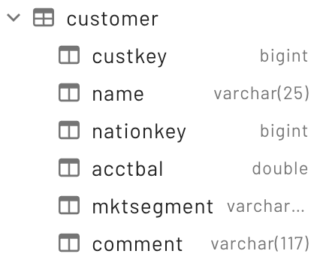

Note: when you have a SELECT * on a table and do not try to project specific columns, Starburst Galaxy omits those columns from the results that the user does not have access to.

Run the following query on just the pii related columns.

SELECT name, phone, address FROM customer;

The error message identifies exactly which columns are the problem; address and phone. The name column is not an issue as it was tagged with the base pii tag, not one of its nested tags.

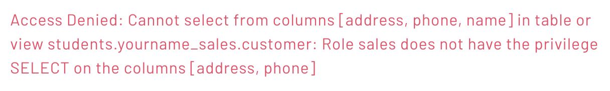

Step 10 - Verify mktg role’s privileges
Just as with the sales role, the mktg role was denied access to the address and phone columns in the customer table. Additionally, it was denied access to the totalprice column in the orders table.

In the upper right corner of the UI, click on the down arrow next to your email address, and change the role selector to use mktg.



The expandable cluster/catalog/schema list will now have the catalogs view collapsed. Drill back into the aws-us-east-1-free cluster and the students catalog. Expand the yourname_sales schema.

The customer and orders tables should be present. Verify that the results from these 3 queries are the same as for the sales role from Step 9.

SELECT * FROM orders o JOIN customer c ON (o.custkey = c.custkey);
SELECT * FROM customer;
SELECT name, phone, address FROM customer;

Verify the mktg role’s restriction on the sales.pricing tagged column, totalprice, does not cause an error, and is ignored, when * is used for the columns to return.

SELECT * FROM orders;

Verify it is a problem when the column is called out specifically.

SELECT orderkey, totalprice FROM orders;

The error message identifies the problem with the totalprice as expected.

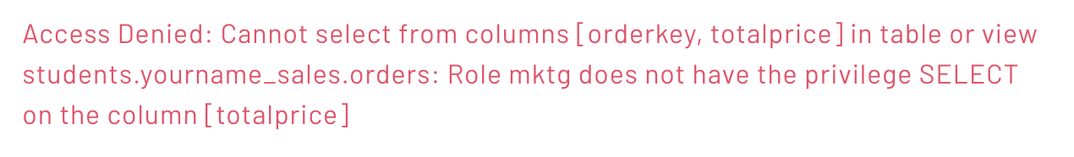

END OF LAB EXERCISE

